1 Single-Choice Questions:
1) For the entropy of a single symbol discrete source , the entropy of the N extended source must satisfy___________.
A. B.
C. D.
2) What is right in the following statement ________.
A. The average mutual information can be negative.
B. The mutual information can be negative in certain condition.
C. For the entropy of certain source, it can increase to infinity.
D. The channel capacity must be larger than any rate distortion function.
3) The ultimate entropy satisfies _________.
A. It must be smaller than any single entropy.
B. It must be larger than for the independent extended source.
C. It should be equal to for the Markov source.
D. It would be larger than for the Markov source.
2 Completion.
a) The components for the Shannon communication system includes_______
, __________ and ____________.
b) As the probability of a certain event increases, its self-information would ___________.
c) For the rate distortion function, R(D_{min})=____, while R(D_{max})=________
(H(X) is the entropy for the source X).
d) For the channel capacity C from the source X to the destination Y, the range for C should be among ______ and ___________ .
3 Assume the probability space of one Discrete Memoryless Source (DMS) is:
If there is a noise channel that the source X gets through, the destination symbol set is Y=[b₁,b₂] and the transition probabilities matrix is:
Then please calculate:
a) I(a₁) and I(a₂); (2 scores) b) H(X); (4 scores) c) H(Y); (4 scores)
d) H(X,Y); (4 scores) e) I(X.Y). (6 scores)

3 There exists a binary 2-step Markov Chain, where the source symbol set is {0,1}. The symbol transition probabilities are:
P(0|00)=P(1|11)=0.6 P(1|00)=P(0|11)=0.4
P(0|01)=P(0|10)=P(1|01)=P(1|10)=0.5.
a) Draft the state transition graph of this source; (4 scores)
b) Give the probability transition matrix; (2 scores)
c) Calculate the probability distribution of stationary state; (6 scores)
d) Please give the ultimate distribution of symbols 0 and 1. (2 scores)

4 If the discrete no memory channel matrix is
A) B)
a) please give the types of channel in A) and B), respectively. (2 scores)
b) Please calculate the channel capacities of A) and B), respectively. (16 scores)
5 If the probability distribution of one DMS is:
a) Please provide the Fenno coding that making sensible and the unique Huffman coding. (10 scores)
b) Please calculate both average code lengths. (4 scores)
c) Please calculate the coding efficiency of both coding methods, respectively. (4 scores)
6 If the generating matrix of (6,3) linear block code is:
G=
a) Provide the code of the message M=(100). (3 scores)
b) Calculate the supervisory matrix H. (4 scores)
c) If the received code is (101111) and the error weight is less than 2, please provide the LBC code. (5 scores)

III. (13 scores) Consider the (6,3) Linear Block Coding, its generation matrix is:
.
a) Encode the message u=[101] into a codeword; (5 scores)
b) Determine the minimum Hamming distance of this code; (6 scores)
c) Explain how this code can detect up to t errors. (2 scores)
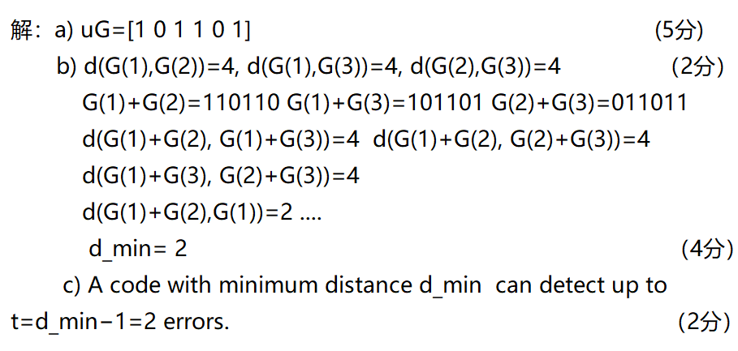
=1 error。
IV. (20 scores) Assume there are 12 examples of school students describing their clothing, weather condition and the health states. The samples spans the entire winter and spring seasons in 2024.
Denote the source X as the weather condition and the probability distribution of X as the proportion of the weather state {cold, comfy, cool}, the destination symbol set Y={healthy, sick}.
Then please calculate:
a) the probability distributions of X and Y; (2 scores)
b) H(X) and H(Y); (8 scores)
c) the joint probability distribution of X and Y, H(X,Y); (6 scores)
d) I(X;Y). (4 scores)
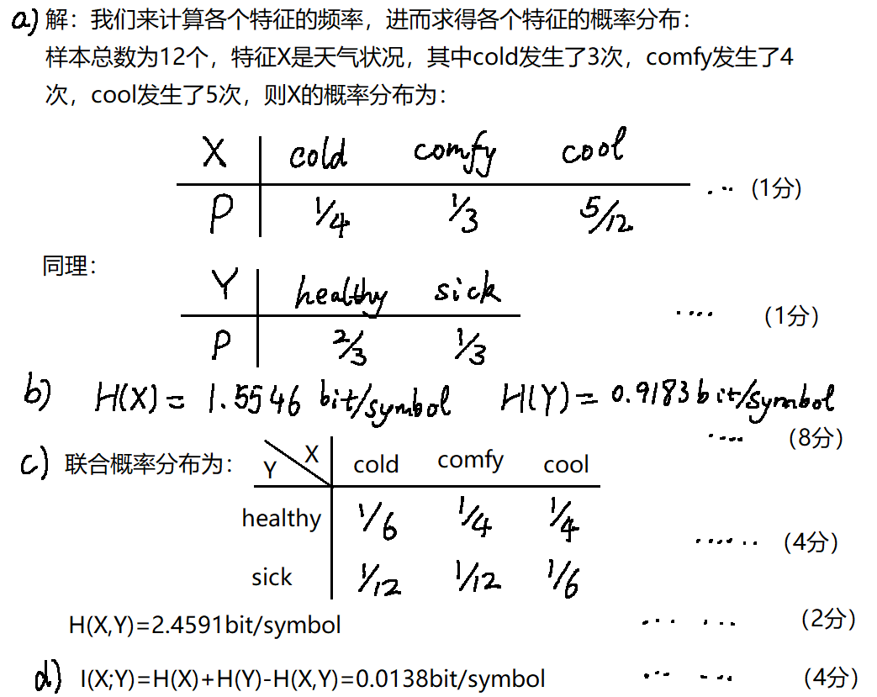
V. (14 scores) A student’s study habits follow a Markov chain with two states: Focused (F) and Distracted (D). The transition matrix is:
.
a) To investigate the magnitude of distribution differences between two states (F and D), please calculate the Jensen-Shannon divergence of the condition distributions of (0.7,0.3) and (0.4,0.6); (6 scores)
b) Find the stationary distribution ; (6 scores)
c) Calculate the limiting entropy of the Markov chain. (2 scores)
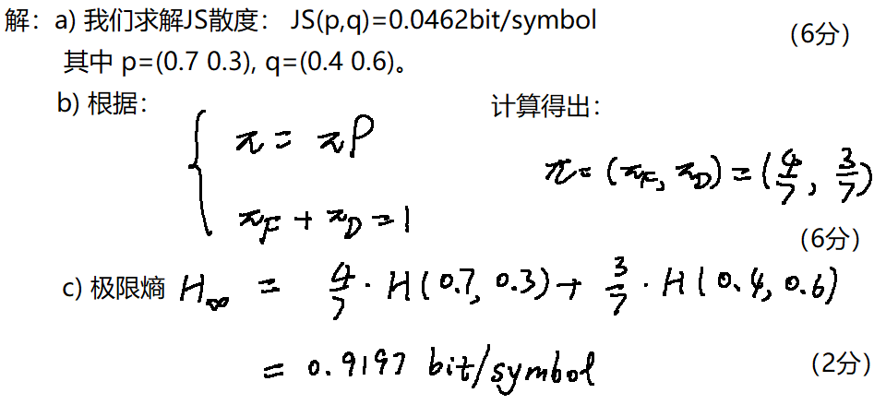
VI. (14 scores) A medical AI system is designed to classify chest X-ray images into three categories: Healthy (H), Pneumonia (P), and Uncertain (U). The system acts as a communication channel where:
Input (True Condition): ;
Output (AI Diagnosis): .
The channel’s behavior is characterized by the following quasi-symmetric transition matrix:
a) Calculate the channel capacity C of this quasi-symmetric channel; (12 scores)
b) If the positions of 0.2 and 0.7 are swapped, please explain from the mechanism whether the channel capacity mentioned above increases, decreases, or remains unchanged. Note that calculations are not required. (2 scores)
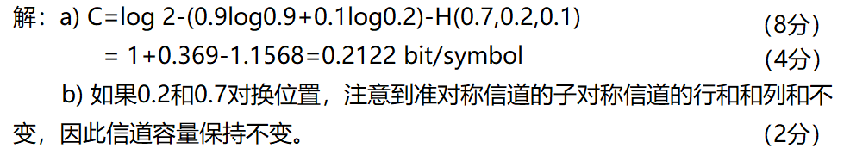
VII. (18 scores) A sensor transmits four types of signals{A,B,C,D} with the following probabilities:
a) Please provide the Huffman coding; (10 scores)
b) Please calculate its average code length; (4 scores)
c) Please calculate the coding efficiency. (4 scores)
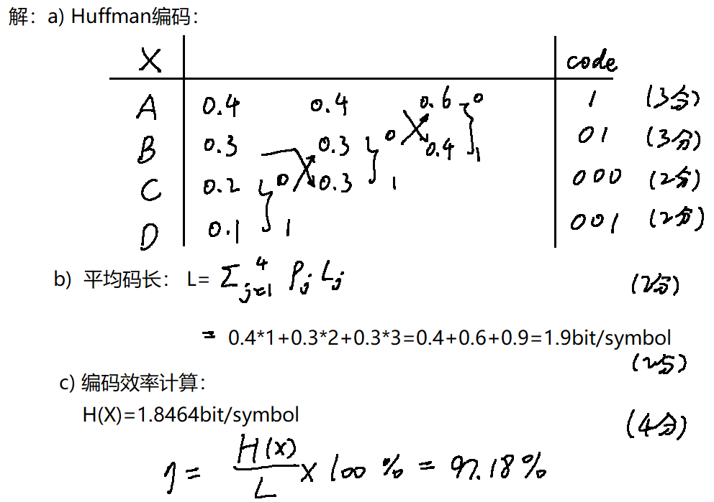

I. (9 scores) Single-Choice Questions:
1) For the entropy of a single symbol discrete source , the entropy of the N extended source must satisfy____B_______.
A. B.
C. D.
2) What is right in the following statement ___B____
A. The average mutual information can be negative.
B. The mutual information can be negative in certain condition.
C. For the entropy of certain source, it can increase to infinity.
D. The channel capacity must be larger than any rate distortion function.
3) The ultimate entropy satisfies ____A____.
A. It must be smaller than any single entropy.
B. It must be larger than for the independent extended source.

C. It should be equal to for the Markov source.
D. It would be larger than for the Markov source.
II. (12 scores) Completion.
a) The components for the Shannon communication system includes_source_
, channel__ and ___destination__.
b) As the probability of a certain event increases, its self-information would ___decrease___.
c) For the rate distortion function, R(D_{min})=__ H(X) _, while R(D_{max})=__ 0__
(H(X) is the entropy for the source X).
d) For the channel capacity C from the source X to the destination Y, the range for C should be among ___0___ and __min{H(X),H(Y)}___ .
III. (20 scores) Assume the probability space of one Discrete Memoryless Source (DMS) is:
If there is a noise channel that the source X gets through, the destination symbol set is Y=[b₁,b₂] and the transition probabilities matrix is:
Then please calculate:
a) I(a₁) and I(a₂); (2 scores) b) H(X); (4 scores) c) H(Y); (4 scores)
d) H(X,Y); (4 scores) e) I(X.Y). (6 scores)
解：a) I(a₁)=-log P(X=a₁)=1 bit
I(a₂)=-log P(X=a₂)=1 bit
b) H(X)=P(X=a₁)* I(a₁)+ P(X=a₂)* I(a₂)
=0.5*1+0.5*1 bit/symbol = 1 bit/symbol
c) P(Y=b₁)=0.6* P(X=a₁)+0.2* P(X=a₂)
=0.6*0.5+0.2*0.5 = 0.4
P(Y=b₂)=0.4* P(X=a₂)+0.8* P(X=a₁)
=0.4*0.5+0.8*0.5 = 0.6
or P(Y=b₂)=1-P(Y=b₁)=0.6
d) H(Y)= -(P(Y=b₁)log P(Y=b₁)+ P(Y=b₂)log P(Y=b₂))
= 0.6* 0.7370+0. 4*1.3219 bit/symbol
=0.971 bit/symbol
e) P(X=a_{1,} Y=b₁)= 0.5*0.6=0.3
P(X=a_{1,} Y=b₂)= 0.5*0.4=0.2
P(X=a_{2,} Y=b₁)= 0.5*0.2=0.1
P(X=a_{2,} Y=b₂)= 0.5*0.8=0.4
H(X,Y)=0.521+0.464+0.332+0.5288bit/symbol=1.846bit/symbol
I(X,Y)=H(X)+H(Y)-I(X,Y)=0.125 bit/symbol

III. (14 scores) There exists a binary 2-step Markov Chain, where the source symbol set is {0,1}. The symbol transition probabilities are:
P(0|00)=P(1|11)=0.6 P(1|00)=P(0|11)=0.4
P(0|01)=P(0|10)=P(1|01)=P(1|10)=0.5.
a) Draft the state transition graph of this source; (4 scores)
b) Give the probability transition matrix; (2 scores)
c) Calculate the probability distribution of stationary state; (6 scores)
d) Please give the ultimate distribution of symbols 0 and 1. (2 scores)
解：a) 自己画

b) P=
c) 记w=( w₁,w₂,w₃,w₄)是(00,01,10,11)的极限分布概率,
由 w*P=w 和 w₁+w₂+w₃+w₄=1,
得
解得：w=( w₁,w₂,w₃,w₄)=(5/18,2/9,2/9,5/18).
d) P(0)=P(0|00)w₁+P(0|01)w₂+P(0|10)w₃+P(0|11)w₄
=0.4*5/18+0.5*2/9+0.5*2/9+0.6*5/18
=1/2
P(1)=1-P(0)=1/2

IV. (18 scores) If the discrete no memory channel matrix is
A) B)
a) please give the types of channel in A) and B), respectively. (2 scores)
b) Please calculate the channel capacities of A) and B), respectively. (16 scores)
解：
a) A:对称信道 B: 准对称信道
b) A: C=log₂m-H(4/5,1/10,1/10)
=log₂3-(0.2575+0.3322+0.3322)
=1.5850-0.9219bit/symbol=0.6631 bit/symbol
B: 分解成如下三个子对称信道矩阵：
B₁=，B₂= ，B₂=
其中 N₁=1/3, M₁=2/3; N₂=1/6, M₂=1/3; N₃=1/2, M₃=1.
C=log₂n-H(1/6,1/3,1/2)-N₁logM₁-N₂logM₂ –N₃logM₃
=log₂2-(0.5+0.5283+0.4308)+1/3log3/2+2/3log3/2
=1-1.459+0.1950+0.39bit/symbol=0.126bit/symbol
V. (18 scores) If the probability distribution of one DMS is:
a) Please provide the Fenno coding that making sensible and the unique Huffman coding. (10 scores)
b) Please calculate both average code lengths. (4 scores)
c) Please calculate the coding efficiency of both coding methods, respectively. (4 scores)
解：
a) Fenno Coding:
X | P |  |  |  | code
a₁ | 0.4 | 0 |  |  | 0
a₂ | 0.2 | 1 | 0 | 0 | 100
a₃ | 0.2 |  |  | 1 | 101
a₄ | 0.1 |  | 1 | 0 | 110
a₅ | 0.1 |  |  | 1 | 111
Huffman Coding:
X | P |  |  |  |  |  |  |  | code
a₁ | 0.4 |  | 0.4 |  | 0.4 |  | 0.6 | 0 | 1
a₂ | 0.2 |  | 0.2 |  | 0.4 | 0 | 0.4 | 1 | 01
a₃ | 0.2 |  | 0.2 | 0 | 0.2 | 1 |  |  | 001
a₄ | 0.1 | 0 | 0.2 | 1 |  |  |  |  | 0000
a₅ | 0.1 | 1 |  |  |  |  |  |  | 0001

b) Fenno coding: K=1*0.4+3*0.2+3*0.2+3*0.1+3*0.1=2.2bit/symbol
Huffman coding: K=1*0.4+2*0.2+3*0.2+4*0.1+4*0.1=2.2bit/symbol

c) H(X)=-(0.4log0.4+0.4log0.2+2*0.1log0.1)bit/symbol
=0.5288+0.9288+0.6644bit/symbol
=2.122bit/symbol

由于两种编码方法平均码长相同，其编码效率都为
VI. (9 scores) If the generating matrix of (6,3) linear block code is:
G=
a) Provide the code of the message M=(100). (3 scores)
b) Provide the supervisory matrix H. (6 scores)
c) If the received code is (101111) and the error weight is less than 2, please provide the LBC code. (5 scores)

解：
a) x=(100)* =(100110)
b) H=
c) x₁=(000)*G=(000000);
x₂=(001)*G=(001101);
x₃=(010)*G=(010011)
x₄=(100)*G=(100110);
x₅=(011)*G=(011110);
x₆=(110)*G=(110101)
x₇=(101)*G=(101011);
x₈=(111)*G=(111000)
计算不同码之间的Hamming距离，可得最小Hamming距离为：
d=min{x_{i}-x_{j}}=min{3,4}=3，可调节的位数最多为1，则错误图样码重最多为1.
伴随式 S=w H^{T}=(1 0 0)^{T}, 则码重为1的错误图样为 (0 0 0 1 0 0),
因此发送的码字为a=w+e=101011.

